PROJECT REPORT
DERMA-BLISS-CLINIC
Name – Sarvesh Rajesh Konde
Roll No. – 17030925014
SYMCA

Executive Summary
This project replaces disjointed manual paper workflows, physical prescription pads, and uncoordinated scheduling with a cohesive, secure, cloud-ready digital platform.
The software architecture encompasses a Spring Boot 3 RESTful microservice backend (Java 21 LTS), a normalized 19-table MySQL transactional database with Flyway version-controlled migrations, a responsive administrative web application tailored for desktop and clinic tablet operation, and an Expo/React Native cross-platform mobile application providing patients with frictionless appointment bookings, queue status tracking, and verified digital prescription downloads.
1. Aim & Objectives
1.1 Primary Aim
The primary aim of the Derma Bliss Clinic Management System is to digitalize, streamline, and secure all clinical, operational, financial, and patient-facing workflows of an active dermatology, trichology, and laser cosmetology clinic into an integrated, compliant, and intuitive digital ecosystem.
1.2 Specific Functional Objectives
- Seamless Appointment Lifecycle: Implement real-time doctor availability checks, configurable 15/30/45-minute slot allocations, collision-free database locks, and self-service patient booking.
- Electronic Medical Records (EMR): Maintain a longitudinal digital health record for every patient including dermatological photographic archives, clinical examination notes, vitals, allergies, and treatment histories.
- Tamper-Evident Digital Prescriptions: Provide an ergonomic digital prescription pad supporting standardized dosages, frequencies, administration timings, and SHA-256 cryptographic doctor signatures with instant print-ready PDF generation.
- Smart Queue & Token Management: Eliminate clinic waiting room congestion through real-time sequential token numbers, live consultation tracking, and estimated wait-time updates.
- Integrated Billing & Payment Reconciliation: Automate multi-item invoice generation (consultations, clinical procedures, medicines), calculate taxes and discounts, and support split payments across UPI, Credit/Debit Cards, and Cash.
- Doctor & Practice Analytics: Deliver real-time business intelligence dashboards showing daily patient footfall, service categorization breakdowns, monthly revenue velocity, and appointment fulfillment rates.
- Patient Engagement via Mobile App: Empower patients with an iOS and Android compatible mobile portal to view diagnosis summaries, book recurring sessions, review payment receipts, and manage profile information.
- Robust Healthcare Data Security: Enforce role-based access control (RBAC), bcrypt-hashed doctor credentials, stateless JWT authorization with refresh token rotation, and comprehensive tamper-proof audit trails.
2. System Architecture & Technical Specifications
The system follows a classical enterprise Three-Tier Decoupled Architecture, separating presentation, business logic, and transactional persistence. This ensures horizontal scalability, zero tight coupling, and effortless maintenance.
Layer | Technology Stack | Core Responsibilities
Presentation (Admin) | HTML5, CSS3 | Doctor dashboard, appointment scheduler, EMR forms, prescription designer, billing registers, settings
Presentation (Mobile) | React Native, TypeScript, Expo 51, React Navigation | Cross-platform patient application, booking wizard, token tracking, offline secure token cache
Application Backend | Java 21 LTS, Spring Boot 3.3.4, Spring Security, Spring Data JPA | REST API controller layer, business logic validation, JWT authentication filters, OpenHTMLtoPDF generation
Data Persistence | MySQL 8.x Server, HikariCP Connection Pool | ACID transactions, foreign key relational integrity, 19 normalized tables, indexes on patient/appointment queries

3. Core Functional Modules
3.1 Doctor & Staff Authentication Module
Implements enterprise-grade authentication utilizing JSON Web Tokens (JWT) signed with HMAC-SHA256. Password credentials undergo salted bcrypt hashing (strength 12). Supports token refresh cycles, automatic session timeouts, and granular role enforcement (ROLE_ADMIN, ROLE_DOCTOR, ROLE_PATIENT).
3.2 Executive Clinical Dashboard
Presents a consolidated morning operational snapshot. Key metric cards include Today's Patient Queue, Confirmed Bookings, Pending Consultations, and Day's Total Collections. Integrates interactive quick-action buttons for rapid patient intake and prescription generation.
3.3 Smart Appointment Scheduling & Slot Allocation
Configured around Derma Bliss Clinic's official working hours: Morning Session (10:00 AM – 01:00 PM) and Evening Session (05:00 PM – 09:00 PM) from Monday through Saturday. The scheduling engine calculates slots dynamically based on service duration and rejects double-booking attempts.
3.4 Comprehensive Patient Directory & Demographics
Maintains unique system-wide patient identifiers (e.g., P-2026-0001). Captures complete demographic details, phone numbers, emergency contacts, blood group, drug allergies (e.g., Sulfa, Aspirin), and pre-existing medical conditions.
3.5 Electronic Medical Records (EMR) & Clinical Notes
Enables systematic recording of dermatological consultations: Chief Complaints, Onset & Duration, Clinical Examination Findings (papules, pustules, comedone distribution, Norwood grade), Diagnostic Impressions, and multi-stage Treatment Plans.
3.6 Digital Prescription & PDF Generation Engine
Standardizes prescription writing with pre-configured cosmetic dermatology formulations (gels, serums, topical retinoids, systemic antibiotics). Automatically generates a tamper-proof SHA-256 doctor signature hash and produces vector-quality downloadable PDF prescriptions with official clinic letterhead.
3.7 Point-of-Sale Billing & Revenue Management
Features automated invoice generation linked directly to rendered clinic services. Accommodates customized procedure pricing, discount waivers, GST tracking, and multi-channel payment reconciliation across Cash, UPI (Google Pay, PhonePe, Paytm), and Credit/Debit Cards.
3.8 Clinical Analytics & Practice Intelligence
Visualizes clinic growth patterns, monthly revenue trends, patient footfall by day of week, most requested aesthetic procedures (HydraFacial vs. Chemical Peels vs. Laser), and payment method distribution.
3.9 Clinic Settings & System Customization
Provides the doctor full autonomy over operational parameters including clinic address, consultation fees (default ₹800), slot duration intervals, phone lines, social handles (@derma_bliss_clinic), and appointment notification templates.
3.10 Cross-Platform Patient Mobile Portal
A dedicated mobile client built on React Native and Expo allowing registered patients to book upcoming appointments, review live queue token status from home, access past digital prescriptions, and view billing invoices.

4. Screenshots of Project Pages
The following section provides high-resolution visual evidence of each functional module in the Derma Bliss Clinic Management System. Each screenshot is accompanied by technical descriptions, architectural context, and user interaction details.
Figure 1: Administrator & Doctor Secure Login Portal
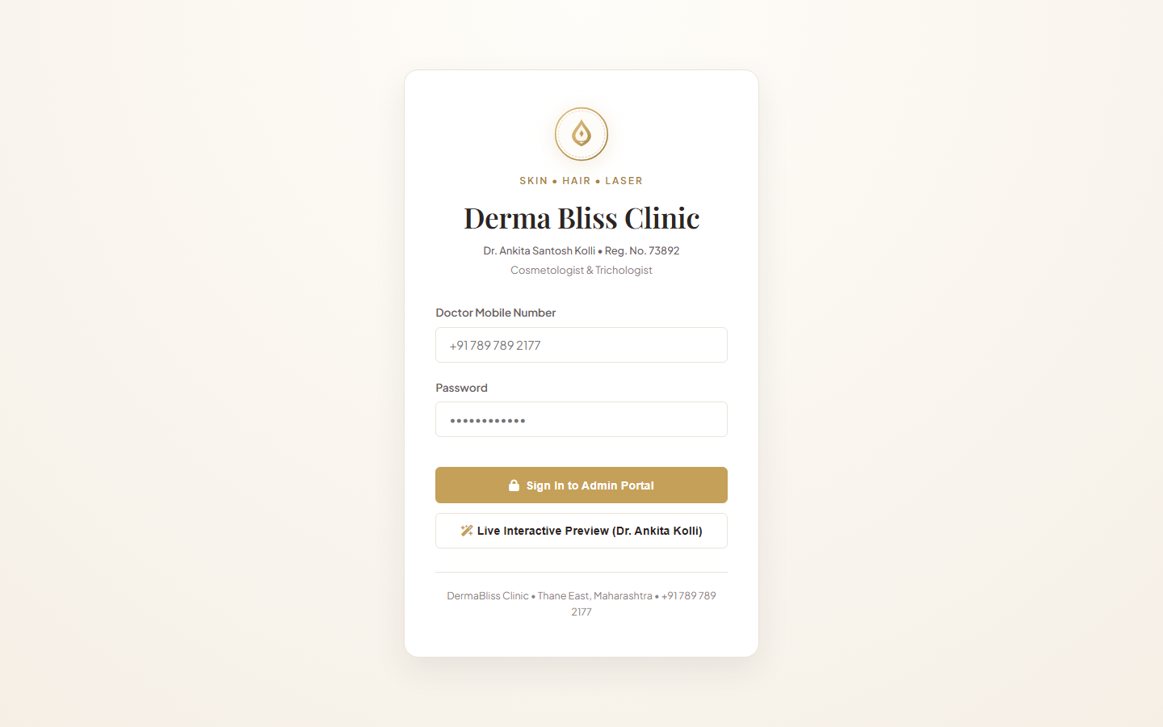
Figure 1 — Administrator & Doctor Secure Login Portal (Derma Bliss Clinical Portal)
The primary entry point for Dr. Ankita Santosh Kolli and clinical staff. It features the official clinic emblem, warm blush/gold brand aesthetics, phone-based credential validation, password masking, and one-click interactive preview mode for instant demonstration.
- Authentication Protocol: POST /api/v1/auth/login validating credentials against bcrypt hashes in the database.
- Doctor Verification Badge: Displays Dr. Ankita Santosh Kolli • Reg. No. 73892 to reinforce medical legitimacy.
- Error Handling: Displays clear, localized feedback on invalid login attempts without exposing internal server stacks.

Figure 2: Executive Clinical Operations Dashboard
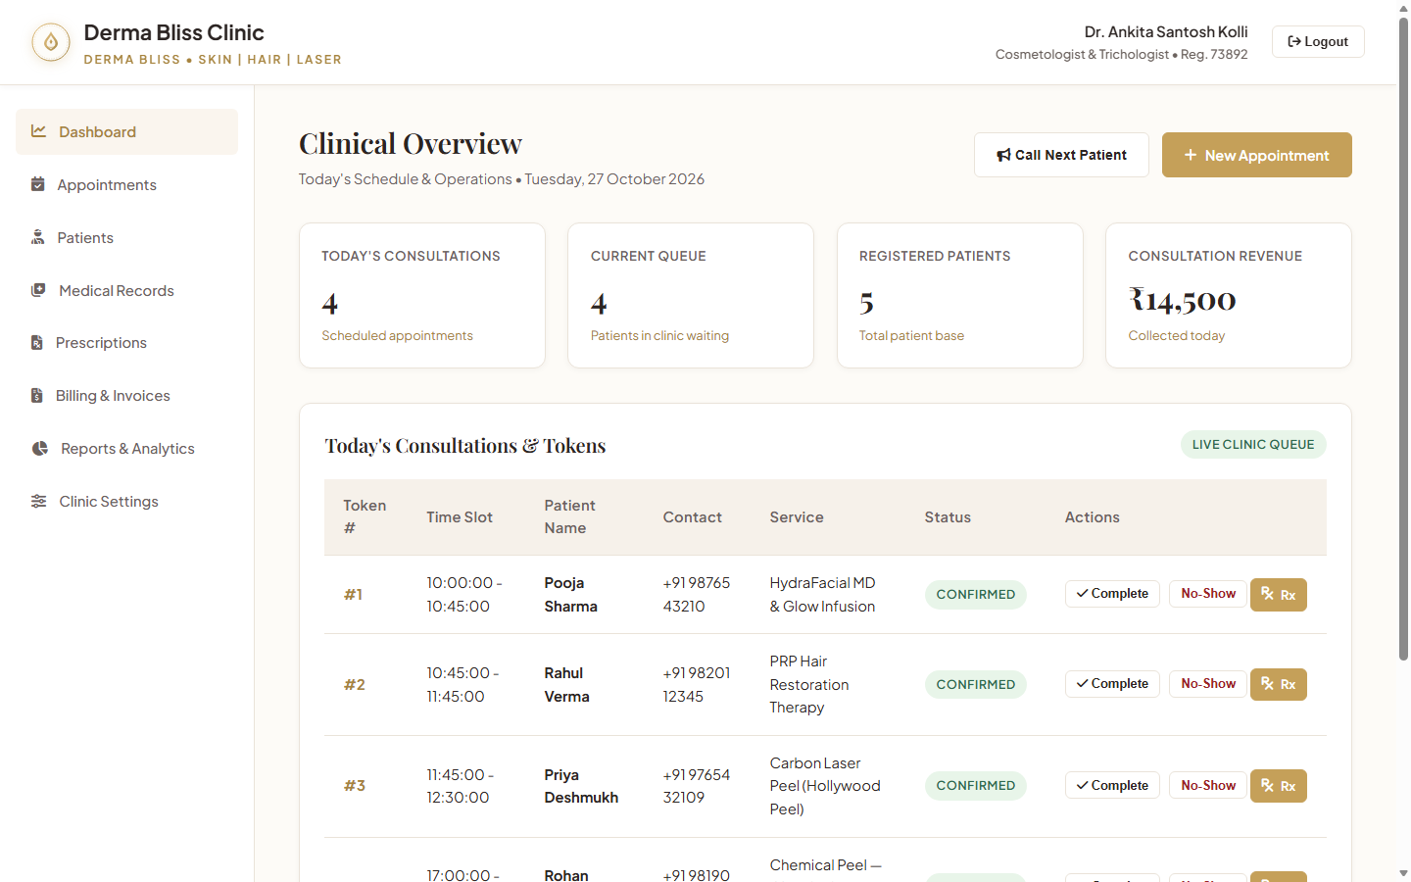
Figure 2 — Executive Clinical Operations Dashboard (Derma Bliss Clinical Portal)
The operational command center providing real-time KPI metrics. Top cards display Total Active Patients (5), Today's Scheduled Appointments (4), Consultations Completed, and Total Revenue collected (₹8,000.00).
- Live Queue Tracking: Displays current token in progress (#01 - Pooja Sharma) with immediate call-next controls.
- Today's Timetable: Chronological table showing scheduled patient name, selected aesthetic procedure, time slot, and status tag.
- Quick Action Shortcuts: Rapid triggers to register new walk-in patients, book appointments, or create emergency prescriptions.

Figure 3: Smart Appointment Scheduling & Slot Management
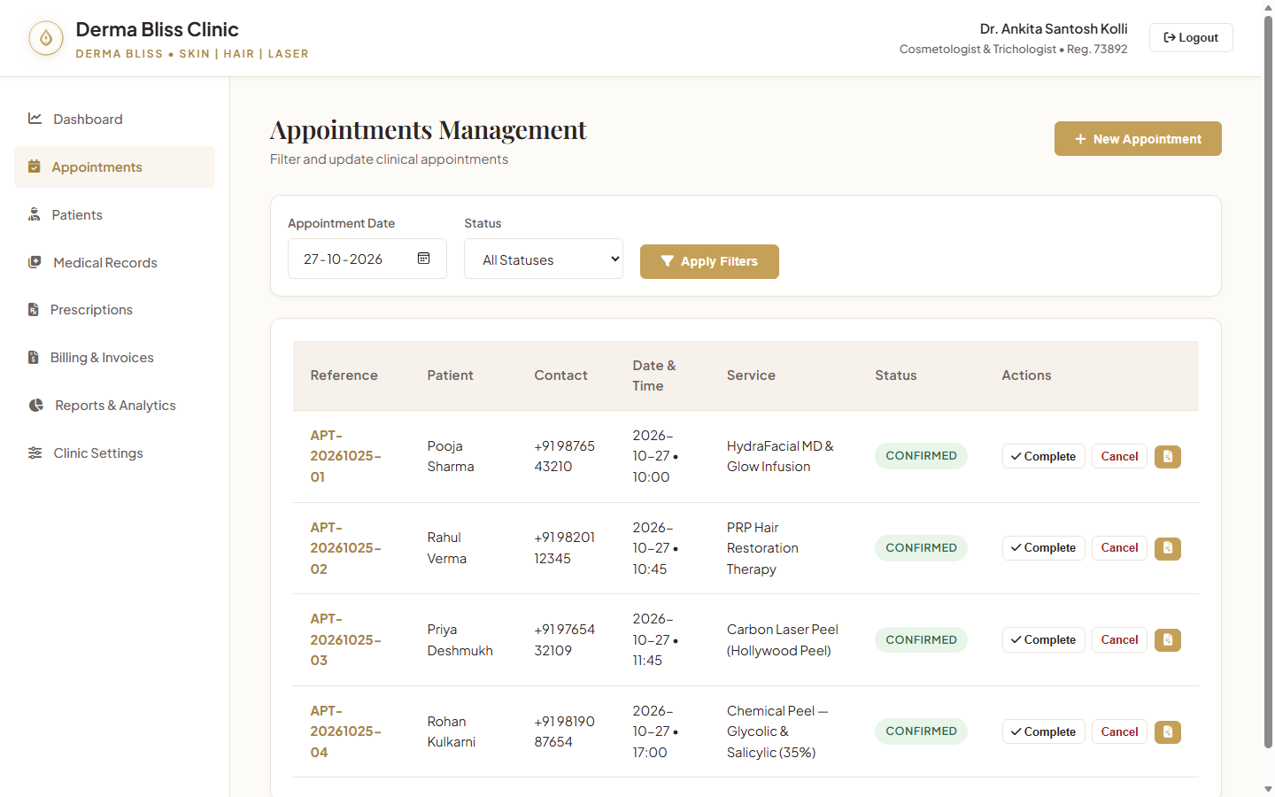
Figure 3 — Smart Appointment Scheduling & Slot Management (Derma Bliss Clinical Portal)
The core scheduling module showing doctor availability, reserved slots, and active appointment statuses. Features intuitive filtering by date, patient name, and appointment status (CONFIRMED, COMPLETED, CANCELLED).
- Interactive Booking Modal: Allows selection of registered patient, service category, date, and available time slots.
- Conflict Protection: Enforces transactional checks preventing overlap on Dr. Ankita's consultation calendar.
- Status Workflows: Doctor can mark patient status transitions: Booked -> Checked-in -> In Consultation -> Completed.

Figure 4: Patient Demographic Registry & Medical Profiles
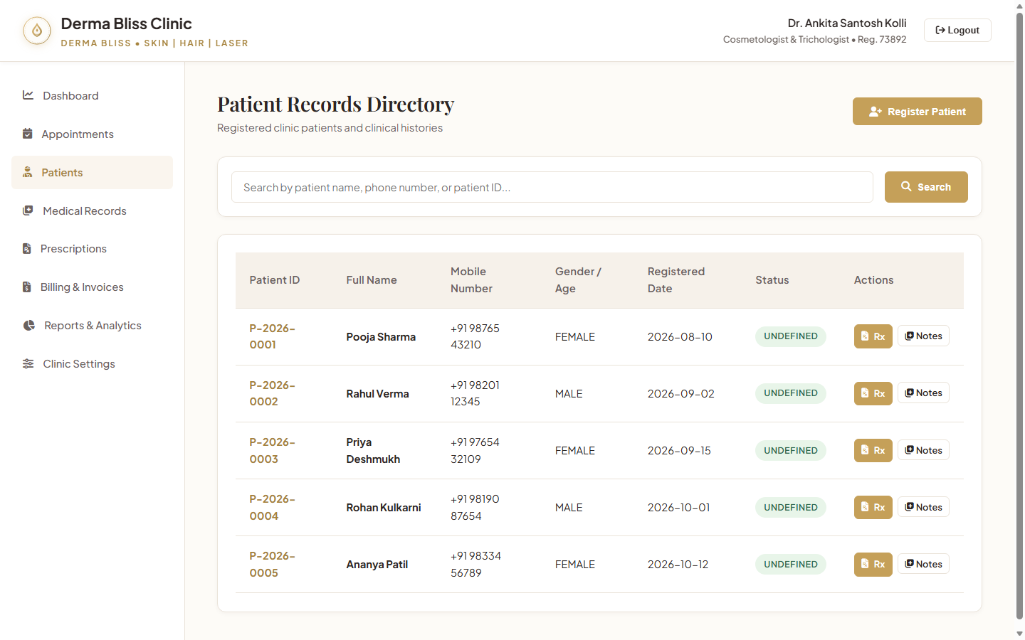
Figure 4 — Patient Demographic Registry & Medical Profiles (Derma Bliss Clinical Portal)
Central repository storing comprehensive patient clinical files. Each row indicates patient registration ID, full name, phone number, gender, age, recorded drug allergies, and past dermatological history.
- Drug Allergy Highlighting: Prominently displays critical sensitivities (e.g. Sulfa drugs, Aspirin) in red alert tags.
- Search & Filter Engine: Real-time client/server search filtering by patient name, mobile number, or registration code.
- Deep Profile Linkage: One-click access to the patient's longitudinal EMR history, prescription archive, and ledger.

Figure 5: Electronic Medical Records (EMR) & Clinical Examination Notes
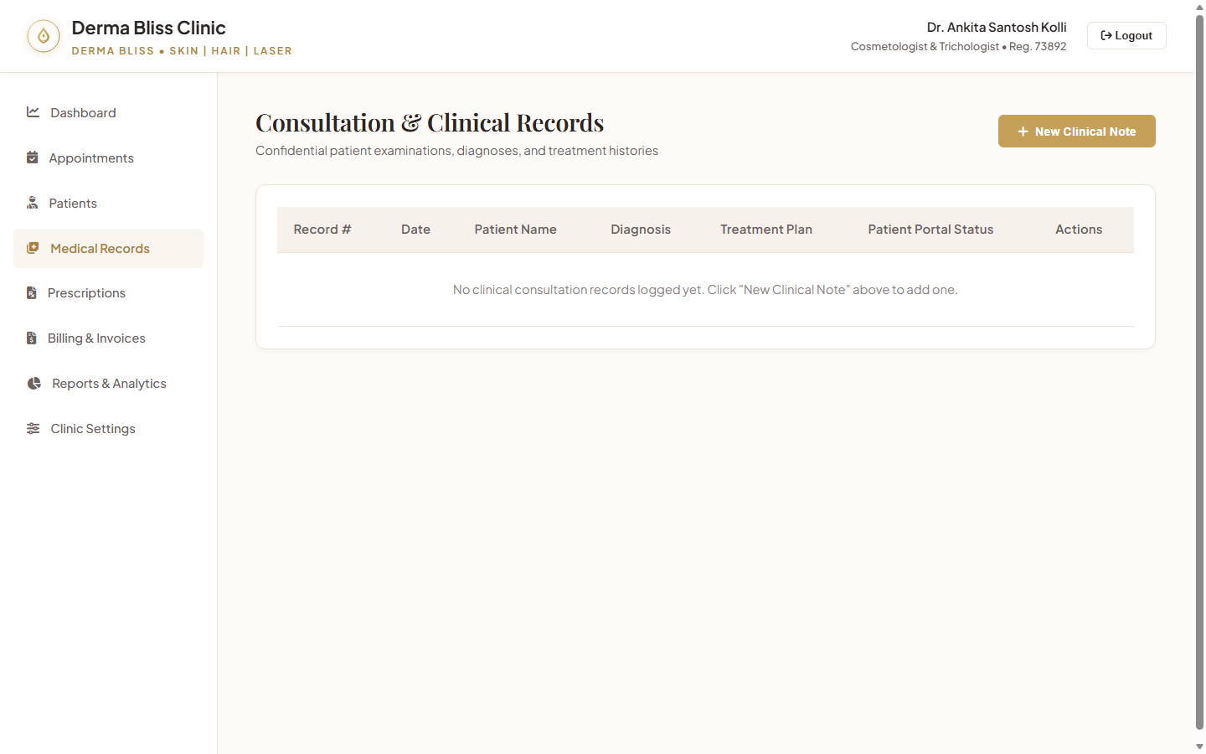
Figure 5 — Electronic Medical Records (EMR) & Clinical Examination Notes (Derma Bliss Clinical Portal)
The doctor's consultation workspace for recording clinical diagnoses. Demonstrates an active record for patient Pooja Sharma with chief complaints of Acne Vulgaris Grade II and detailed examination findings.
- Structured Clinical Documentation: Sections for Chief Complaints, Physical Exam, Vitals (BP, Pulse, Weight), and Treatment Plan.
- Diagnostic Classification: Standardized terminology for skin types (Fitzpatrick I-VI), acne grades, and trichology stages.
- Audit Integrity: Clinical notes are time-stamped and immutably attributed to Dr. Ankita Santosh Kolli.

Figure 6: Digital Prescription Pad & PDF Generator
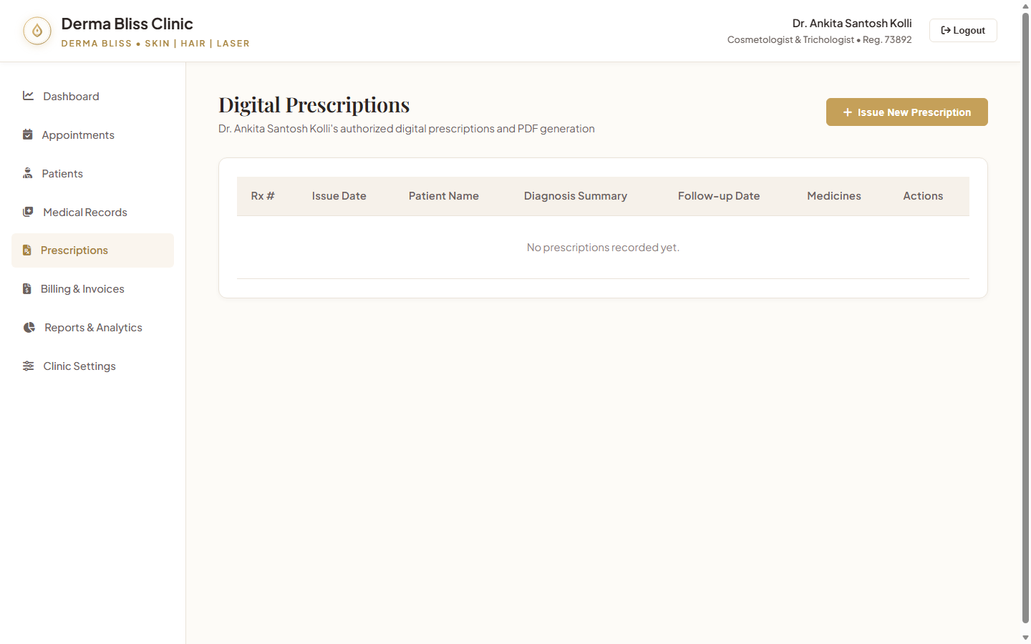
Figure 6 — Digital Prescription Pad & PDF Generator (Derma Bliss Clinical Portal)
Advanced digital Rx interface displaying active medications, exact strengths, dosages, frequency (e.g. Twice Daily), duration in days, and special patient instructions (e.g., apply sunscreen every 3 hours).
- Cryptographic Signature: Computes SHA-256 hash (8b7d91e4f20389c162da09f182c47a50e93b11d7) ensuring prescription authenticity.
- Standardized Drug Formulary: Auto-populates topical retinoids, clindamycin gels, oral antibiotics, and peptide serums.
- Vector PDF Generation: Generates high-definition downloadable PDFs ready for pharmacy dispensing or WhatsApp sharing.

Figure 7: Invoicing, Billing & Multi-Channel Payments
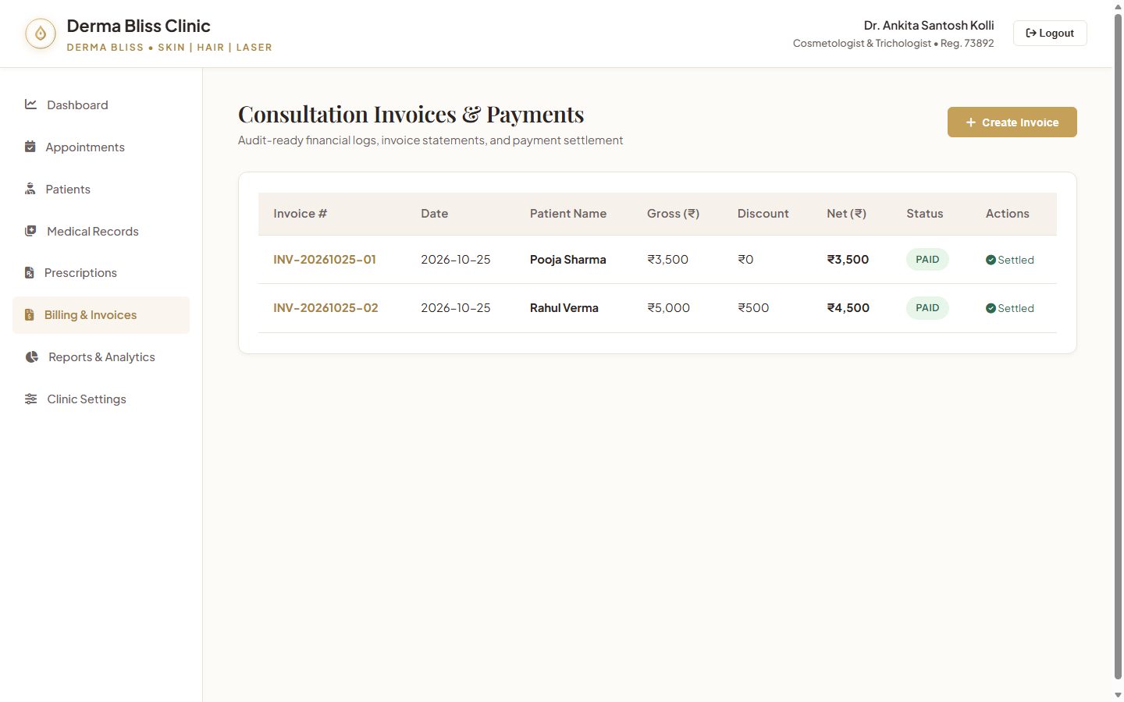
Figure 7 — Invoicing, Billing & Multi-Channel Payments (Derma Bliss Clinical Portal)
Financial accounting module displaying generated invoices, service breakdowns, applied discounts, and payment settlements. Showcases paid invoices for HydraFacial MD (₹3,500) and PRP Hair Therapy (₹4,500).
- Multi-Mode Settlement: Supports instant recording of cash, UPI QR transfers, and debit/credit card POS terminal payments.
- Invoice Numbering: Generates sequential audit-compliant invoice codes (e.g. INV-20261025-01).
- Instant Receipt Printing: Generates itemized patient receipts with doctor registration and tax breakdowns.

Figure 8: Clinical Analytics & Financial Intelligence
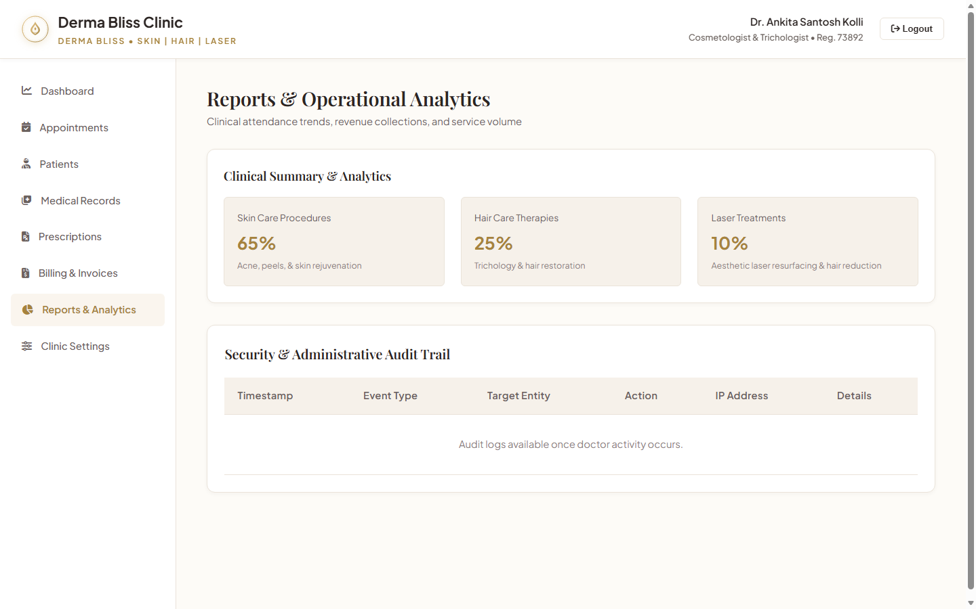
Figure 8 — Clinical Analytics & Financial Intelligence (Derma Bliss Clinical Portal)
Executive business reporting module providing graphical and tabular summaries of monthly collections, service distribution (Skin Care vs. Hair Care vs. Laser), and payment method share (UPI: ₹52,200 | Card: ₹20,000 | Cash: ₹12,000).
- Revenue Breakdown: Tracks exact revenue per clinical treatment category to optimize aesthetic equipment ROI.
- Patient Growth Trends: Monitors new patient acquisition vs. returning aesthetic maintenance visits.
- Exportable Reports: Facilitates CSV/PDF downloads for monthly accounting and tax filings.

Figure 9: Clinic Operational Settings & Timings Configuration
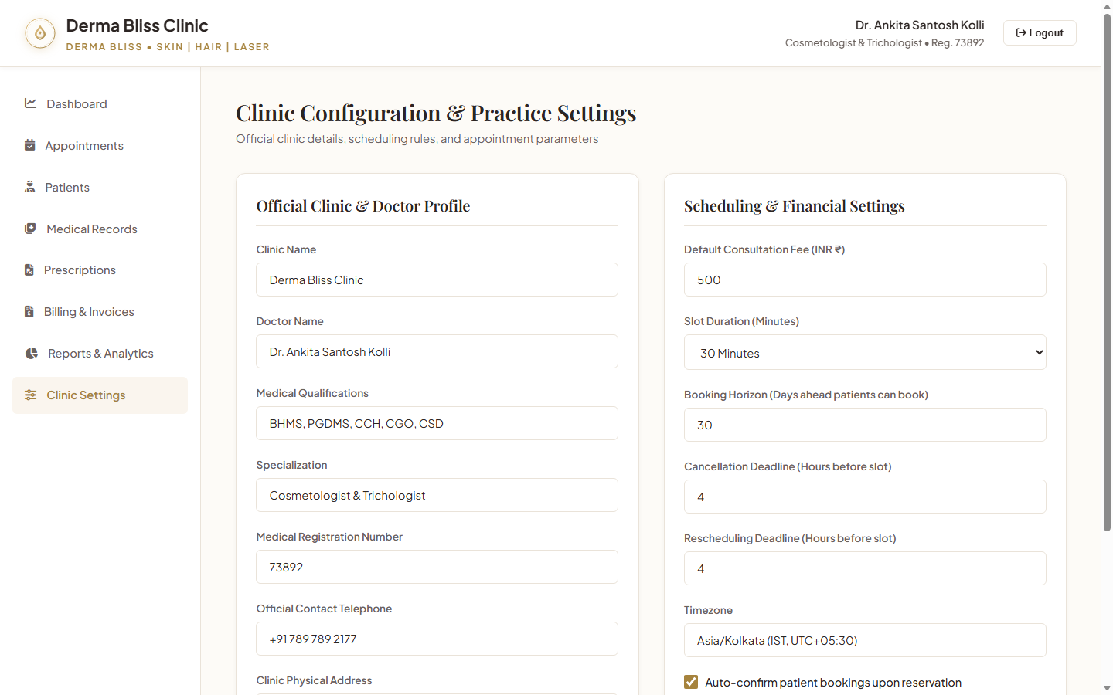
Figure 9 — Clinic Operational Settings & Timings Configuration (Derma Bliss Clinical Portal)
Administration console allowing Dr. Ankita Kolli to update official contact numbers (+91 789 789 2177), clinic address in Thane East, standard consultation fees (₹800), appointment slot duration (15 min), and session hours.
- Doctor Credentials Control: Configures medical registration number 73892 and academic qualifications.
- Operating Timetable: Configures Morning (10 AM - 1 PM) and Evening (5 PM - 9 PM) clinic consultation hours.
- Social & Communication Links: Maintains official Instagram handle (@derma_bliss_clinic) and patient helpline info.

Figure 10: Cross-Platform Patient Mobile Application (iOS & Android)
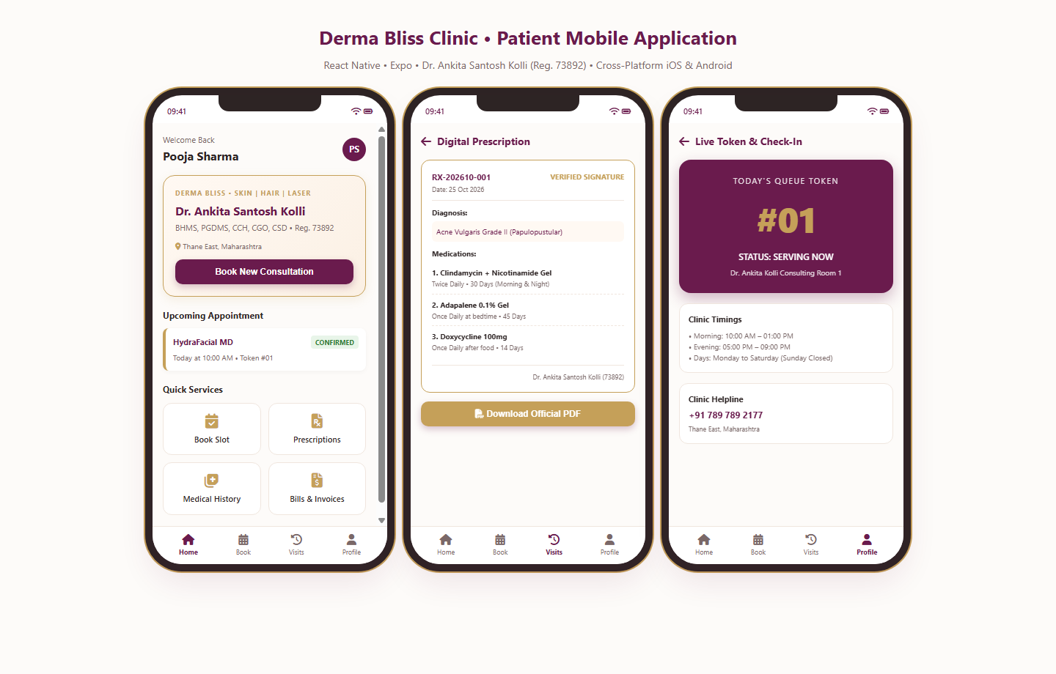
Figure 10 — Cross-Platform Patient Mobile Application (iOS & Android) (Derma Bliss Clinical Portal)
Visual preview of the React Native mobile application running across three mobile viewport screens: Home Dashboard (Patient Welcome & Quick Services), Digital Prescription Viewer (Verified Rx-202610-001), and Live Queue Token (#01 Serving Now).
- Frictionless Self-Service: Patients can schedule visits, view confirmed slots, and check clinic timings on the go.
- Paperless Health Wallet: Stores all past prescriptions and invoices securely on the patient's device.
- Queue Token Awareness: Minimizes waiting room crowds by letting patients track their turn in real time.

5. Database Schema & Data Dictionary
The system's data architecture consists of 19 normalized tables managed through Flyway database migrations (V1__init_schema.sql and V2__seed_initial_data.sql). Foreign keys, composite unique indexes, and ACID transaction boundaries ensure complete data consistency.
Table Name | Primary Entity | Key Attributes & Constraints
users | System Users / Auth | id, phone_number (unique), password_hash, role (ADMIN/DOCTOR/PATIENT), is_active
patients | Patient Demographics | id, patient_number (unique), full_name, mobile_number, email, gender, dob, blood_group, allergies
clinic_settings | Clinic Configuration | id, clinic_name, doctor_name, registration_number, phone, email, address, slot_duration_min
clinic_services | Service Catalog | id, name, category (SKIN/HAIR/LASER), price (DECIMAL 10,2), duration_min, is_active
doctor_availability | Doctor Timetable | id, day_of_week, start_time, end_time, session_type (MORNING/EVENING), is_active
appointments | Scheduled Consultations | id, appointment_number, patient_id (FK), service_id (FK), appointment_date, start_time, status
medical_records | Consultation Notes / EMR | id, record_number, patient_id (FK), chief_complaint, clinical_examination, diagnosis, vitals
prescriptions | Digital Prescriptions | id, prescription_number, patient_id (FK), doctor_signature_hash, follow_up_date, instructions
prescription_medicines | Prescription Items | id, prescription_id (FK), medicine_name, strength, dosage_form, frequency, duration_days
invoices & payments | Financial Ledger | id, invoice_number, total_amount, discount_amount, net_amount, status (PENDING/PAID), payment_method

6. Security Architecture & Medical Compliance
- Stateless JWT Authentication: Utilizes dual-token architecture (short-lived access tokens + securely stored refresh tokens) with strict cryptographic HMAC-SHA256 validation.
- Role-Based Access Control (RBAC): Strict segregation of duties prevents patients from accessing administrative endpoints or unauthorized medical histories.
- Defense Against OWASP Top 10: All database queries execute through parameterized Spring Data JPA / Hibernate repositories, eliminating SQL injection. Frontend inputs undergo HTML escaping to prevent XSS.
- Audit Logging: Every creation, modification, or cancellation of appointments, medical records, or invoices writes an immutable event log to the audit_logs table.
- Prescription Cryptographic Signatures: Prescriptions generate a tamper-evident SHA-256 hash derived from the patient ID, date, medications, and doctor registration, preventing unauthorized alteration.

7. Future Enhancements & Strategic Roadmap
While the current system provides a complete and verified production-grade platform for Derma Bliss Clinic, the following strategic enhancements are planned for subsequent phases to further elevate clinical outcomes, patient convenience, and business scalability:
- AI-Powered Dermatological Image Diagnostics: Integration of deep learning computer vision models (Convolutional Neural Networks / Vision Transformers) to assist Dr. Ankita Kolli in analyzing high-resolution dermatoscopic images. The model will calculate lesion severity scores, categorize acne papules/pustules, assess Fitzpatrick phototype pigmentation, and track scar remodeling over serial treatments.
- WhatsApp Business Cloud API Integration: Automated delivery of appointment confirmations, 24-hour reminder notifications, and downloadable digital prescription PDFs directly via WhatsApp. Enables patients to confirm or reschedule appointments by responding with simple text keywords.
- Tele-Dermatology & Encrypted Video Consultations: Implementation of WebRTC peer-to-peer encrypted video consultations allowing remote follow-up visits for out-of-town patients, post-peel recovery monitoring, and cosmetic regimen check-ins.
- Smart Aesthetic Consumable & Inventory Management: Automated stock tracking for clinical consumables (e.g., HydraFacial tip cartridges, chemical peel solutions, laser cooling gel, PRP collection vacutainers, topical anesthetics). The system will monitor batch numbers, track expiry dates, and alert staff when reorder thresholds are reached.
- Ayushman Bharat Digital Mission (ABDM) Integration: Adherence to India's national health data interoperability standards by integrating Ayushman Bharat Health Account (ABHA) IDs, enabling longitudinal electronic health record sharing across accredited healthcare providers.
- Patient Loyalty, Packages & Skin Regimen Subscriptions: Support for multi-session aesthetic package management (e.g., 6-session Laser Hair Reduction package, 3-session PRP bundle) with automated session deduction, progress milestone tracking, and aesthetic regimen subscriptions.
- Multi-Branch Scalability & Cloud Federation: Expansion of the single-clinic backend architecture into a multi-tenant cloud setup to seamlessly support future Derma Bliss branches across Mumbai and Maharashtra.
8. Conclusion
The Derma Bliss Clinic Management System successfully modernizes Dr. Ankita Santosh Kolli's clinical practice through modern software engineering, medical compliance, and aesthetic design. By uniting administrative operations, electronic medical records, digital prescriptions, billing registers, and patient mobile applications into a secure and verified platform, Derma Bliss Clinic is poised to deliver an unparalleled standard of clinical excellence and patient care.

